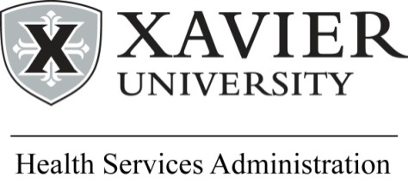 | HEALTH MINISTRIES ASSOCIATION  Conference Presenter Bio  Sister Dr. Nancy Linenkugel, OSF  (2018)

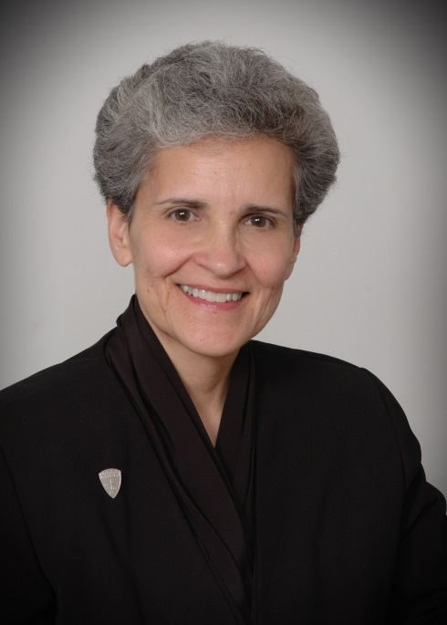 | Sister Nancy Linenkugel is a Franciscan Sister who brings 13 years of experience in the education ministry, 30 years of experience in the healthcare ministry, four years’ experience on the elected Leadership Team of her order – the Sisters of St. Francis of Sylvania, OH. She has also served on a variety of local, regional, and national healthcare boards, including the American College of Healthcare Executives and the CHI Texas Board.  Sister Nancy is currently chair of the department of Health Services Administration and director of the graduate MHSA program at Xavier University (Masters of Health Services Administration.  She was inducted into the State of Ohio Women’s Hall of Fame in 1999, was one of 12 “Up and Comers” nationally in 1990 by MODERN HEALTHCARE magazine, and was the 1990 National Runner-Up for the “Young Healthcare Executive of the Year” Award from the American College of Healthcare Executives.

She received the ATHENA Award in 1992 as Erie County’s (Ohio) Businesswoman of the Year and in 2012 was honored as one of 30 international ATHENA recipients from 5,000 awardees as a 30th Anniversary honoree. She is a church organist and a cellist with various groups, including the National Medical Musical Group in Washington, DC, the Cincinnati Metropolitan Orchestra, the Xavier University Chamber Orchestra, and XU’s Magis String Quartet. She is a volunteer reader for the “Radio Reading Service” of the Cincinnati Association for the Blind and Visually Impaired and reads the WALL STREET JOURNAL weekly on the air. Sister Nancy has been a member of the Sisters of St. Francis, Sylvania, Ohio since 1968.

