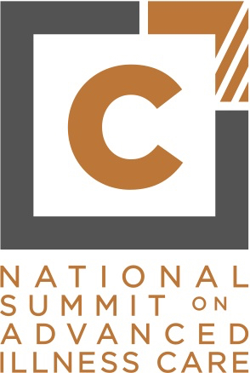

Newsletter Copy (7/25/16):
Each year, C-TAC hosts the National Summit on Advance Illness Care – the premier event for visionaries in advanced illness care who are actively reshaping the way care is provided. Join us September 20-21st, 2016 at the National Academy of Sciences in Washington, DC to network with the greatest minds in the industry and key influencers from a range of specialties including policy, healthcare delivery, payment models, community supported care, and more.
Key Speakers:
- Bishop J.W. Macklin, 2nd Assistant Presiding Bishop, Churches of God in Christ International
- B.J. Miller, M.D., Senior Director and Advocate, Zen Hospice Project and Assistant Clinical Professor of Medicine, University of California, San Francisco
- Nancy Brown, CEO, American Heart Association
- Lucy Kalanithi, MD, FACP, Stanford School of Medicine
- Diane Meier, MD, Director, Center to Advance Palliative Care

Innovative Sessions:
- Emerging faith-based approaches to supporting care delivery for those living with advanced illness
- Caregiving: Current Environment, Best Practices and Next Steps

Please visit www.ctacsummit.org/agenda, to see the full agenda of speakers and concurrent sessions. To ensure dynamic participation of all experts, C-TAC provides scholarships to be used towards admissions, travel and accommodations. For more information about scholarships please contact jbuente@thectac.org. Application process ends August 12th.

