Facilitating Mental Health, Physical Wellness, and Spiritual Well-being
Through Nurse Coaching

https://thumbor.forbes.com/thumbor/960x0/https%3A%2F%2Fblogs-images.forbes.com%2Ftrevornace%2Ffiles%2F2018%2F04%2Fmilennials-flat-earth2.jpg

Margaret Erickson, PhD, RN, MSN, CNS, APHN-BC
Erlanger, KY
September 8, 2018

- Our Philosophy
  - We all have a philosophy and worldview that guides our life choices
    - It affects/impacts our perceptions about God, people, health, the environment, nursing.
    - It also impacts our values, attitudes, beliefs, how we see life, and actions we take.
    - Perceptions Differ According to our Worldview

  - It also affects how we see others and our nursing practice.
Taking Charge | Aggressive
Facilitating | Directing
Patient-Centered | Patient Focused
Emotionally Present | Physically Present
In Control | Manipulative
Client | Patient
Engagement and Adherence | Compliance
Unmet Needs | Needy
Connected | Dependent
Limitations | Disabilities

- Two different philosophical paradigms to consider include Wholism vs. Holism.
- Wholism
  - Most nursing programs approach and teach nursing curriculum from a “wholistic” perspective.
  - People are composed of multiple subsystems: physical, emotional, psychosocial, spiritual, etc.
  - Sum of the parts equals the whole.
  - People have subsystems and the subsystems can be cared for independently of the other parts of the person. Case example: The Heart Attack in Room 228.
  - Nursing Care is fragmented and is based on the subsystem being cared for.
  - Focus tends to be mechanistic, people are reduced to their parts.
  - Care focuses on tasks and curing.
- Holism
  - Holistic Nursing programs focus on a way of being, the interface and integration of the art and science and are grounded in a holistic paradigm.
  - People are believed to be composed of subsystems, that are constantly interacting, creating a synergy that always affects the whole being.
  - Parts are intimately interconnected and explicable only by reference to the whole.
  - The whole is greater than the sum of the parts.
  - People cannot be reduced to a part, disease, system, etc. Case example: The man with the broken heart.
  - Focus is on a way of being and facilitating healing. Curing may occur but it is not the focus of care.
  - People are believed to be spiritual beings with a spiritual core and spiritual energy.
- Our philosophy also impacts how we define Health.
- J. Smith’s Models of Health (1981)
  - Clinical- health is determined by the absence of illness and or disease. Relates to physical status.
  - Role-Performance- A person is healthy if they are able to perform the roles they assume in their life.
  - Adaptive- focus is on person’s ability to adapt to health conditions. I.e. A person who is living with chronic health problems.
  - Eudaemonistic- a holistic perspective. Considers all subsystems and how they impact on one another. Focus is on wellbeing and quality of life as defined by the person. Case examples: Broken Hearted, Ernie-bilateral amputee.
- Future Trends in Nursing and Healthcare
  - Focus is on health promotion, wellness, well-being, and quality of life.
  - Relationship-based, Patient-centered care.
  - Client driven.
  - Open dialogue between person and healthcare providers.
  - Empowerment of the client.
  - Community based care when possible.
  - Shift from volume to a value-based system
  - Higher quality at a lower cost.
  - Requires collaboration among consumers, physicians, health care systems.
  - Patient-Centric World
    - Patient’s time is as valuable as a doctor’s time. Convenience new competitive currency.
    - Patients expect and demand a retail-consumer experience.
    - Beginning shift in decision making moving from Drs. to consumers and payers.
  - Consumers Are Becoming Avid Researchers
    - 1/3 American adults have gone online to figure out a medical condition.
    - 72% of Internet users looked online for health information in past year.
    - 47% of Internet users search for information about doctors or other health professionals.
    - 38% of Internet users search for information about hospitals and other medical facilities.
  - Digital Content Key to the Decision Process. According to Think with Google’s The Digital Journey to Wellness: Hospital Selection:
    - 84% of patients use both online & offline sources for hospital research.
    - Search drives nearly 3x as many visitors to hospital sites compared to non-search visitors.
    - Patients primarily search on SX and condition terms
    - 44% of patients who research hospitals on a mobile device scheduled an appointment.
- Challenges
  - Healthcare system is broken.
  - Pharmaceutical and Big Business driven.
  - Consumer experience and satisfaction poor-now driving reimbursement.
  - Powerbase in medicine vs. consumers and stakeholders.
  - Shortage of nurses
  - Nurse attrition problematic.
  - High acuity with low staffing.
  - High repeat admissions.
  - Opioid crisis.
- Opportunities Ahead
  - Facilitating Transformation of the Healthcare System
  - In this Process How Do We Predict and Achieve the Desired Outcomes?
- Nurse Coaching- A new role in Nursing- based on holistic nursing
  - Based on a foundation of Holism
  - Goal is healing the whole.
  - Draws on nursing knowledge, theories, expertise, skills, and the nursing arts.
  - Creates therapeutic partners with people in their care.
  - Recognizes totality of the human being - the interconnectedness of spirit, body, mind, emotion, social/cultural, relationship, context, and environment.
- Competencies Essential to Role of Nurse Coaching
  - Building a therapeutic relationship through the Nurse Coach process.
    - Creating a sacred, safe environment free of distractions.
    - Care provided is developmentally appropriate and sensitive to culture and ethnicity.
    - Engagement vs. Directing or Giving Advice- Case Example-Elderly native American
    - Facilitating sense of control vs. controlling person-Who is driving the sled/holding the reins?
    - Healing therapies- i.e. Journaling, expressive arts, meditation, mindfulness, etc.
    - Support and facilitate self-care for client and nurse.
  - Expert Communication skills
    - Clear, Conscious, intentional, purposeful, and compassionate.
    - What are our words conveying?
Childish | Young
Disabled | Crippled
Handicapped | Retarded
Easy-Going | Couch Potato
Slender | Skinny
Cheap | Frugal
Young | Immature
Interested | Nosy
Conversational | Chatter Box

    - Active and Deep Listening-use of silence and pauses.
    - Deep questioning
    - Direct communication
    - Use of integrated and holistic communication skills such as Motivational Interviewing and multiple ways of knowing to facilitate clarification, validations, self- discovery and identification of needs and concerns.

  - Clarification and specification of client-centered goals.
  - Outcomes
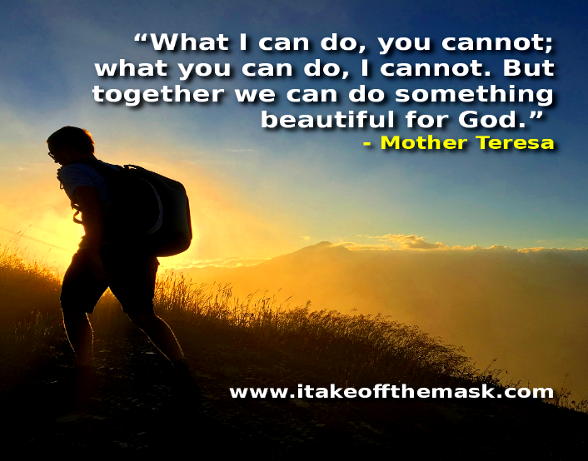
    - Everyone on the same page for communication
    - Connections are made
    - Clients are engaged
    - Collaboration occurs
    - Goals are achieved
- The Future
  - Implications and Relevance:
  - Education
  - Practice
  - Leadership
  - Research
- Nurse Coach Competencies- http://www.ahncc.org/wp-content/uploads/2017/12/FINAL-REVISED-NC-Core-Essentials-DOC-4-12-2017.pdf.
- Questions and answers.

